DevOps : Devops is a software Development approach which involves continuous development, continuous testing, continuous integration, continuous deployment and continuous monitoring of the software throughout its development lifecycle.
GIT : It is a open source distributed version control system designed for speed and efficiency.
In order for collaborating of source code and collaboration of work done by various s/w teams we need a version control.
USE : There are 100’s developers writing code for various software projects inside a company. All this developers are located in a different place and working as different projects. So there should be a centralized location where all of the source code is available. There is also way to deploy your application and all in this situation we need GIT
MAVEN : Maven is a build automation tool.
USE : You have the code in your local system, so we can not give the code to testing team like that, so we have to build that code and then we need to give that code to testing team. And the output of the build is a jar file, so we have to give this jar file to testing team.
Jenkins :Jenkins is a configuration tool. It is a tool which has the connectivity between every tool and it can just bring together all the tools in the devops and make it together and work.
Jenkins Dashboard :
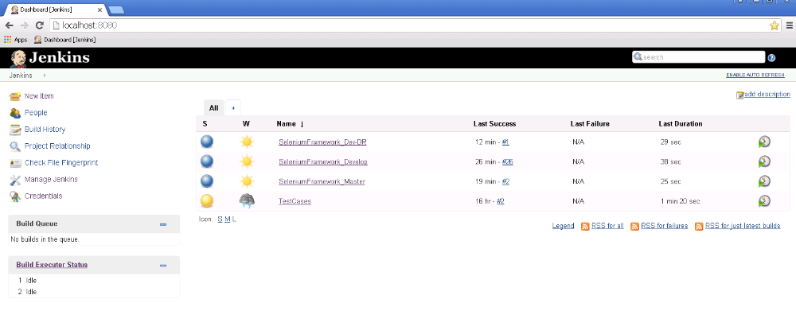

Manage Jenkins Option :
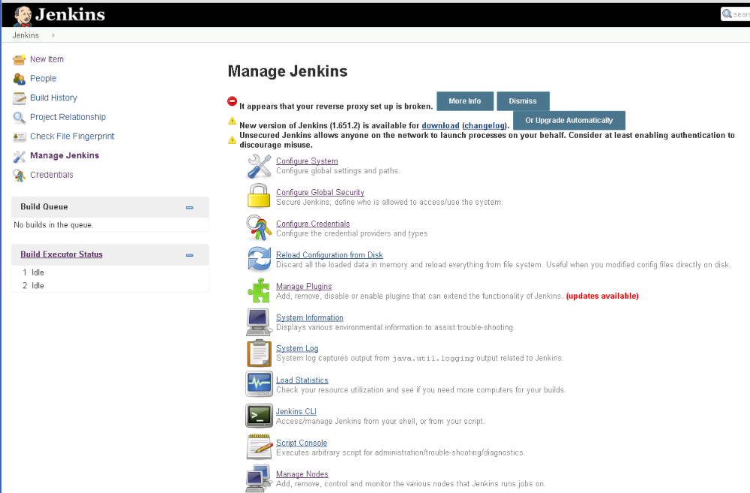

Manage Jenkins : Configure System
Go to Manage Jenkins → Configure System
Set the path for the libraries and tools you will need for your project:
- JDK
- Maven
- Git

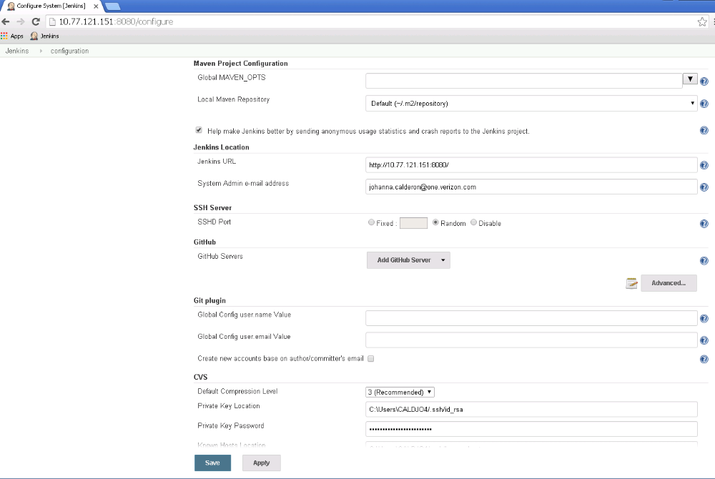

Jobs :

- Click on New Items, to create a new job.
- Pick the project type and add a Name for the job.
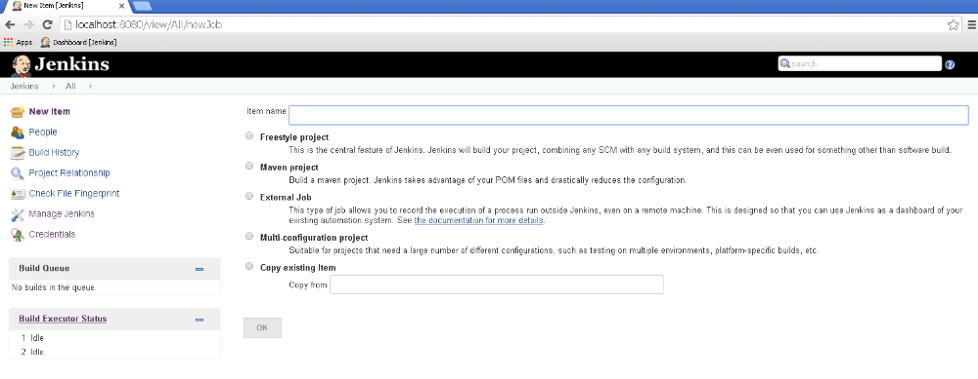

- Click on Configurations.
- Check Discard olds builds to control the amount of builds keep by Jenkins in the server. Andd the days or max builds to keep.

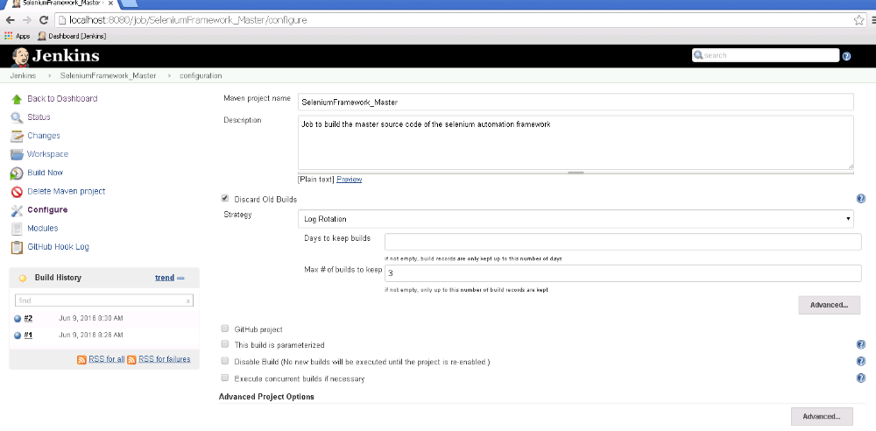

- Check Git, and add the repository url. If credentials are required add here too.
- Select the branch you want to use for this job.
- On Build options: indicate the location of the pom file (for maven projects) and add the goal you what the job to execute.
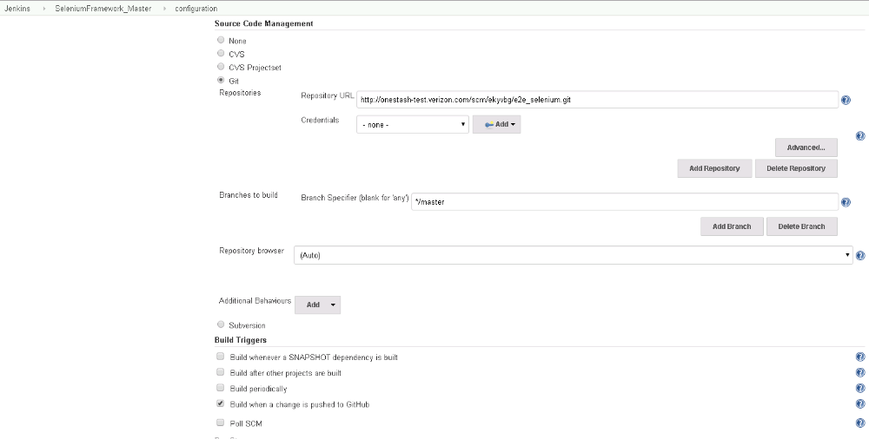
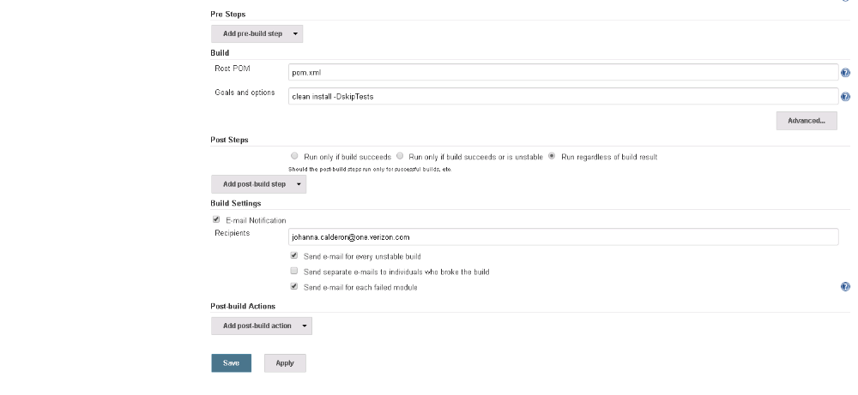
- After all the configurations then click save
- The job dashboard screen:
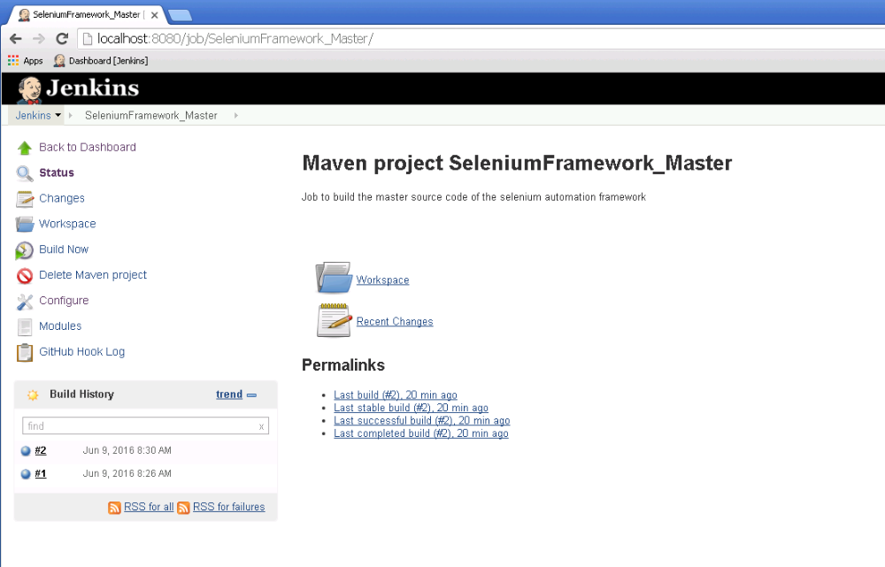

- The job Workspace screen (source code cloned in Jenkins workspace)
